CREDIT ENHANCEMENT PROGRAM | GOVERNMENTAL UNIT NOTIFICATION OF  POTENTIAL DEFAULT | 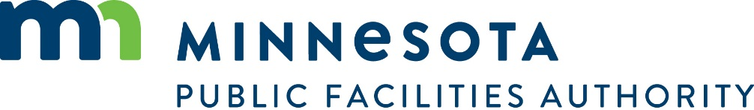

GENERAL INFORMATION AND INSTRUCTIONS: In accordance with the provisions of Minnesota Statutes, Section 446A.086, Subd. 3 and the Credit Enhancement Program Agreement (the “Agreement”), if a governmental unit believes that it may be unable to make a principal or interest payment on bonds covered under the Agreement on the date that payment is due, it must notify the Minnesota Public Facilities Authority as soon as possible, but not less than 15 working days before the date that principal or interest payment is due. Cities and Counties should be advised that the Authority will forward this information to bond rating agencies.

To notify the Minnesota Public Facilities Authority of a potential default, call (651) 259-7469 and fax this form to (651) 296-8833.

GOVERNMENTAL UNIT INFORMATION
Name of Governmental Unit | Telephone Number |  | Fax Number
Name of City/County Contact Person |  | Title

DEBT OBLIGATION INFORMATION
Title/Description of Bonds |  |  | Date Issued | Dated Date
Payment Due Date | Amount Of Principal And  Interest Due On Payment Date | $ | Amount Govt Unit Is Unable To Pay On Payment Date |  | $

Paying Agent Information

Name of Paying Agent | Address |  | City | State | Zip Code
Paying Agent Contact Person | Title |  | Telephone Number | Fax Number
Paying Agent’s Name of Bank |  | Paying Agent’s Bank Account Name
Bank Association Number |  | Paying Agent Bank Account Number
Paying Agent Federal Tax ID |  | State Tax ID

