CREDIT ENHANCEMENT PROGRAM | PAYING AGENT NOTIFICATION OF POTENTIAL DEFAULT | 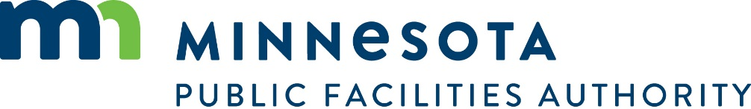

GENERAL INFORMATION AND INSTRUCTIONS: In accordance with the provisions of Minnesota Statutes, Section 446A.086 Subd. 3 and the Credit Enhancement Program Agreement (the “Agreement”), a governmental unit that issues bonds covered under the Credit Enhancement Program must deposit with the paying agent three business days before the date on which each payment is due on the bonds an amount sufficient to make that payment. If a paying agent becomes aware of a potential default on bonds covered under the Program, or if on the day two days before the date a payment is due, there are insufficient funds to make the payment on deposit with the paying agent, the paying agent must immediately inform the Minnesota Commissioner of Management and Budget and the Minnesota Public Facilities Authority. Governmental units are advised that the Authority will forward this information to bond rating agencies.

IN THE EVENT OF A DEFAULT OR POTENTIAL DEFAULT:
- NOTIFY THE COMMISSIONER OF MANAGEMENT AND BUDGET BY CALLING (651) 201-8010 AND FAXING THIS FORM TO (651) 296-7714.
- NOTIFY THE MINNESOTA PUBLIC FACILITIES AUTHORITY BY CALLING (651) 259-7469 AND FAXING THIS FORM TO (651) 296-8833.

GOVERNMENTAL UNIT INFORMATION
Name of Governmental Unit | Telephone Number | Fax Number
Name of City/County Contact Person | Title

DEBT OBLIGATION INFORMATION
Title/Description of Bonds |  |  | Date Issued | Dated Date
Payment Due Date | Amount Of Principal And  Interest Due On Payment Date | $ | Amount of Additional Funds Needed to Make Payment |  | $

Paying Agent Information

Name of Paying Agent | Address |  | City | State | Zip Code
Paying Agent Contact Person | Title |  | Telephone Number | Fax Number
Paying Agent’s Name of Bank |  | Paying Agent’s Bank Account Name
Bank Association Number |  | Paying Agent Bank Account Number
Paying Agent Federal Tax ID |  | State Tax ID

PAYING AGENT CERTIFICATION OF INFORMATION AND REQUEST FOR PAYMENT | I hereby certify that the above information is accurate. I hereby request that the State of Minnesota make payment of the amount which the Governmental Unit is unable to pay on the date due, as listed above.
 | ___________________________________________________________________  Signature - Responsible Authority | _______________  Date

FOR STATE USE ONLY
MINNESOTA PUBLIC FACILITIES AUTHORITY REQUEST FOR MAKING OF PAYMENT | I hereby request the Commissioner of Management and Budget establish an open appropriation in following amount and that payment to the Paying Agent be approved.
 | Amount  $ | _______________________________________________  Signature – Executive Director or Designee  Minnesota Public Facilities Authority | _____________  Date
1-17

