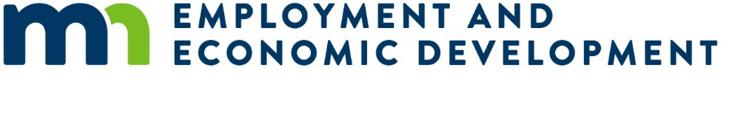

# Small Cities Development Program (SCDP) 2025 Preliminary Proposal

## Multi-Family Rental Housing Rehabilitation Proposal with Minnesota Housing Fund Tax Credit

### Submission Deadline

Applicants must submit one original and one copy of the Preliminary Proposal to the Department of Employment and Economic Development (DEED) on or before 4:00 pm, Wednesday, November 27, 2024.

Faxed or emailed applications will not be accepted.

## Instructions

Applicants **must review** the Small Cities Development Program (SCDP) Application Guide from the [SCDP Website](https://mn.gov/deed/government/financial-assistance/community-funding/small-cities.jsp) (https://mn.gov/deed/government/financial-assistance/community-funding/small-cities.jsp).

This preliminary proposal is **only** for a Multi-Family Rental Rehabilitation Proposal in conjunction with Minnesota Housing Fund Tax Credit. Complete each section as appropriate. Other types of rental housing or any other preliminary proposals are located on the [SCDP Website](https://mn.gov/deed/government/financial-assistance/community-funding/small-cities.jsp).

Rehabilitation of renter occupied residential structures that are completely or primarily occupied by low-and-moderate income households will need to meet affordable rents during the life of the loan. Affordable rents should be clearly identified and appropriate to the community and persons served and shall not exceed HUD’s Section 8 Fair Market Rents.

* Property owners must enter into agreements for occupancy and rents before rehabilitation begins. Minimum rehabilitation standards to be applied are HUD’s Section 8 Housing Quality Standards (HQS).
* The maximum amount of SCDP assistance for multifamily rental is $12,500 per unit.
* The maximum percentage of SCDP assistance per building is 70% of the total project cost.
* The term for SCDP funds must be structured, at a minimum, as a five (5) year deferred loan (no loan forgiveness for 5 years).
* Target area must be citywide, regardless of population – no Plan B contingency areas.
* Federal national objective at least 51% of the units must be occupied by low-and-moderate (LMI) income households (80% of the county median income) and HUD rent restrictions must be met.
* Federal Davis-Bacon Act applies to buildings with eight (8) or more units.

## Multi-family rental in conjunction with Minnesota Housing Fund Tax Credit

Applicant Name:

### Project Description

Provide a brief description of the activity:

#### Community Questions

Multi-community applications must include responses for all proposed communities.

* Primary community:
* Population of primary community:
* Partnering community #2 (if applicable):
* Population of partnering community #2 (if applicable):
* Partnering community #3 (if applicable):
* Population of partnering community #3 (if applicable):

### Need

* List proposed work items to be completed and assigned to this grant:
* Construction date of the building (month/year):
* Date of last major rehabilitation project (month/year):
* Number of units in the building are ADA compliant:
* If the property owner plans on increasing rents, describe how it will occur without the displacement of current tenants:

Provide a brief description of the project need. At minimum, describe:

1. Unique designations,
2. Geographic or demographic concerns,
3. Inadequate supply of existing housing stock, including lack of new housing stock, etc.,
4. Any previous grants, and how this grant could build on those results.

Narrative answer for project need:

### Impact

* Number of units in the building that are currently occupied:
* After rehabilitation, number of units that will be designated for LMI households with affordable rents:
* For buildings with more than four (4) units, is substantial rehabilitation proposed as defined by 24 CFR 5.100?
  + Yes
  + No
* For building with more than four (4) units with substantial rehabilitation proposed, is there justification to include installation of broadband infrastructure as defined by 24 CFR 570.202(g)?
  + Yes
  + No
* If units could be ADA compliant, explain the necessary work elements. DEED SCDP could allow extra funding per unit for ADA compliant units:
* If the building is currently vacant, how will the rent structure be comprised?
* Rental vacancy rate of the city:      %
* If community vacancy rate is more than 10%, provide narrative to what factors will increase demand for rehabilitated rental units:
* Does the property have a post-rehabilitation maintenance and capital expenditure budget plan:
  + Yes
  + No
* Choose the rent standard that will apply to the LMI units:
  + HUD Fair Market Rents: rent + utility costs do not exceed HUD’s published FMR:
  + Payment Standard: section 8/voucher payment standard for the number of bedrooms in each unit:
  + 60% rent: affordable rent at 60% of area median income, adjusted for household size (only applicable with MN Housing HOME Funds):

Provide a brief description of the project impact. At a minimum, describe:

1. The proposed target area expected impact on the community or communities,
2. How did you determine the proposed number of multi-family rental homes to be served (unit goal),
3. List the deficiencies identified,
4. Any other projects of economic or community development, not associated with SCDP, that the community plans to undertake that could impact this project,
5. What is the applicant’s plan to reach underserved groups in the community?

Narrative answer for project impact:

### Cost Effectiveness

* Will Rental Rehabilitation Deferred Loan (RRDL) or Public Owned Housing Program (POHP) funds from Minnesota Housing, be used to assist in the funding of this project?
  + Yes
  + No
* If RRDL or POHP funds are not going to be used, explain why?
* Commitment date for RRDL or POHP funding:
* Percentage of SCDP assistance per building (cannot exceed 70%)%):      %
* Length of SCDP deferred/forgivable loans (minimum of 60 months from project completion):
* If the proposed financing will also include an SCDP funded installment loan, complete the following:
  + What percentage of the SCDP funds will be an installment (where regular payments are required) loan?
  + What is the length of the installment loan?
  + What is the interest rate of the installment loan?

Briefly describe the cost effectiveness of the project. At a minimum, describe:

1. How the proposed program will encourage multi-family rental building owner participation,
2. Experience of the administrator in implementing SCDP or similar grants and existing capacity.

Description of cost effectiveness: