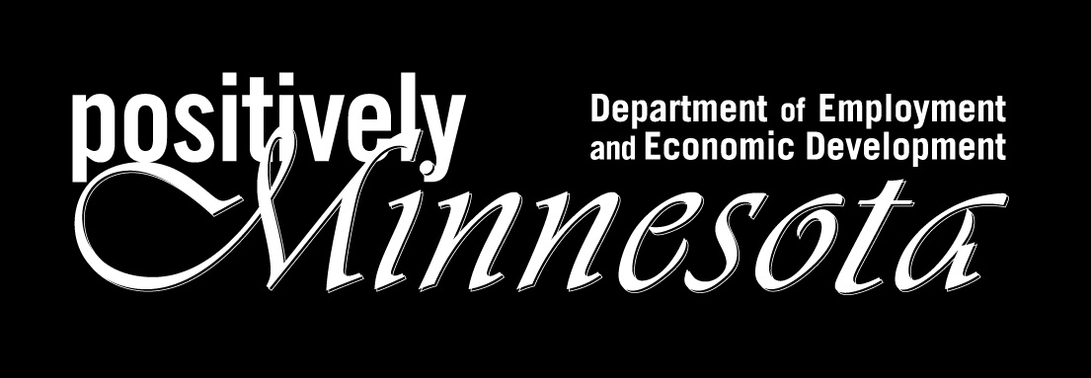

SEED Capital Investment Credit
Business Certification
Application

Please submit one copy of the application to:

Minnesota Department of Employment and Economic Development
Business and Community Development Division
Attn: Jeff Nelson
1st National Bank Building
332 Minnesota Street, Suite E200
Saint Paul, MN 55101-1351

651-259-7523
1-800-657-3858
TTY/TDD: 651-297-5353
Fax: 651-296-8833
Application Type

1) Initial Certification: _____

2) Recertification: _____ Initial Certification Date: _____________

Business Name: ______________________________________________________

Primary Contact Name: _______________________________________________

Business Address: ____________________________________________________

_____________________________________________________________________

Business Phone: _______________ Business Website: ____________________

Federal Tax EIN: _______________ Minnesota Tax ID: ___________________

Primary Sector Business Qualification

Describe how your business, through the employment of knowledge or labor, adds value to a product, process, or service:

______________________________________________________________________

______________________________________________________________________

______________________________________________________________________
Describe how your business increases revenues by generating sales of products or services to customers outside Minnesota, OR,

Describe how your business increases revenues by acquiring customers previously unable to purchase (or had limited availability to purchase) products or services from a Minnesota provider:

______________________________________________________________________

______________________________________________________________________

______________________________________________________________________

______________________________________________________________________

______________________________________________________________________

Type of Business Qualification

Sole Proprietorship: _____

Partnership: _____ Type of Partnership: _____

LLC: _____ State of Incorporation: _____

S Corp: _____ State of Incorporation: _____

C Corp: _____ State of Incorporation: _____

Non-Profit: _____ State of Incorporation: _____

Real Estate Investment
Trust: _____

Status of Business:

New: _____

Existing: _____ Date Established: ____________

Securities Law Compliance Qualification

Indicate one (1) of the following:

_____ This business is required to be registered and make securities filings with the Minnesota Department of Commerce

_____ This business is exempt from registering and making securities filings with the Minnesota Department of Commerce

Border City Qualification

Provide the address of your business’s principal office or satellite operation within Minnesota:

______________________________________________________________________

______________________________________________________________________

What is the number of employees at this location? _____ as of ________
Or
What is the number of projected employees at this location? _____ as of _____

What is the number of employees at this location that are Minnesota residents?

_____

Is this location within a border city’s (as defined in Minn. Stat. 469.1713)
development zone? _____

Describe your business activity at this location:

______________________________________________________________________

______________________________________________________________________

______________________________________________________________________

______________________________________________________________________
Do the majority of your business’ activities (except sales activities) take place at this location? (if so, explain), OR

Is your business activity at this location a significant operation that has or is projected to have more than 10 employees or $150,000 in annual sales? (if so, explain):

______________________________________________________________________

______________________________________________________________________

______________________________________________________________________

______________________________________________________________________

Business Plan Qualification

Describe your business’ plans for growth and profitability. Include in this description your business’ current or future plans for reliance on innovation, research, or the development of new products and processes:

______________________________________________________________________

______________________________________________________________________

______________________________________________________________________

______________________________________________________________________

Signature

I declare that any statement in this application, or information provided herein, is true and complete to the best of my knowledge and hereby acknowledge that I have read and understand the following statement:

“The State of Minnesota and its agents have the right to verify information provided in this application. False information, in addition to disqualifying the applicant from any further consideration for financial assistance, may also subject the applicant to the penalty provision of Minnesota Statute Sec. 609.645.”

Applicant Name: _____________________________________________________

Applicant Signature: ________________________________________________

Applicant Title: _____________________________________________________

Date: _____________________________________________________

.

